TASK 4.1

CODE

<!DOCTYPE html>

<html lang="en">

<head>

    <meta charset="UTF-8">

    <meta http-equiv="X-UA-Compatible" content="IE=edge">

    <meta name="viewport" content="width=device-width, initial-scale=1.0">

    <title>Lab_04_1799</title>

    <style>

        h1{font-family: Arial, Helvetica, sans-serif;

        font-size: 26pt; color: red; text-transform: capitalize;}

        p{font-size: 12pt; font-style: italic;font-weight: bold;

        color: #23238e;border: groove;border-width: thick;}

    </style>

</head>

<body>

</body>

<h1>Silicon chip technologies</h1>

<p>

lA private limited company, which was founded in December 1989. The <br>

    vision of this company is to provide any corporate client a single entity <br>

    which addresses all their Software Development, Technical and User <br>

    Documentation, Training and Manpower Recruitment needs.

</p>

</html

OUTPUT

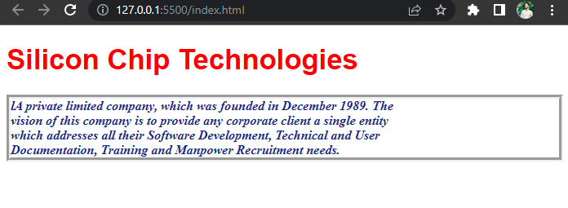

TASK 4.2

CODE

<!DOCTYPE html>

<html lang="en">

<head>

    <meta charset="UTF-8">

    <meta http-equiv="X-UA-Compatible" content="IE=edge">

    <meta name="viewport" content="width=device-width, initial-scale=1.0">

    <title>Lab_04_1799</title>

    <link rel="preconnect" href="https://fonts.googleapis.com">

    <link rel="preconnect" href="https://fonts.gstatic.com" crossorigin>

    <link href="https://fonts.googleapis.com/css2?family=EB+Garamond&display=swap" rel="stylesheet">

    <style>

        h1 {

            font-family: 'EB Garamond', serif;

            font-size: 26pt;

            color: red;

            text-transform: capitalize;

        }

        ul {

            list-style: square;

        }

    </style>

</head>

<body>

</body>

<h1>Silicon chip technologies</h1>

<p>SCT provides Corporate Training for the following products</p>

<ul>

    <li>HTML</li>

    <li>Javascript</li>

    <li>CGI</li>

    <li>Java</li>

    <li>Oracle Developer 2000</li>

    <li>Oracle DBA</li>

</ul>

</html

OUTPUT

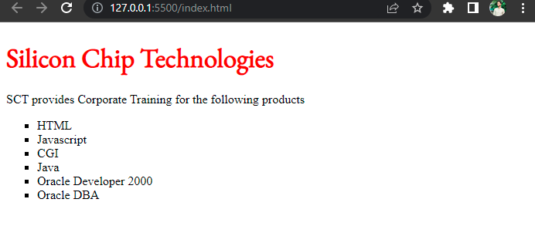

TASK 4.3

CODE

<!DOCTYPE html>

<html lang="en">

<head>

    <meta charset="UTF-8">

    <meta http-equiv="X-UA-Compatible" content="IE=edge">

    <meta name="viewport" content="width=device-width, initial-scale=1.0">

    <title>Lab_04_1799</title>

    <link rel="preconnect" href="https://fonts.googleapis.com">

    <link rel="preconnect" href="https://fonts.gstatic.com" crossorigin>

    <link href="https://fonts.googleapis.com/css2?family=EB+Garamond&display=swap" rel="stylesheet">

    <style>

        .heading1 {

            font-family: 'EB Garamond', serif;

            font-size: 26pt;

            color: red;

            text-transform: capitalize;

        }

        .list {

            list-style: circle;

        }

    </style>

</head>

<body>

</body>

<h1 class="heading1">Silicon chip technologies</h1>

<p>SCT provides Corporate Training for the following products</p>

<ul class="list">

    <li>HTML</li>

    <li>Javascript</li>

    <li>CGI</li>

    <li>Java</li>

    <li>Oracle Developer 2000</li>

    <li>Oracle DBA</li>

</ul>

</html

OUTPUT

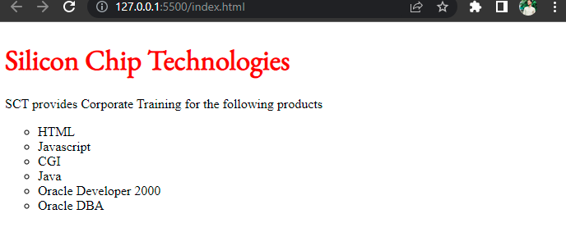

TASK 4.4

CODE

 <html>

 <head>

 <title> ID SELECTOR </title>

 <style type="text/css">

 p {font-size:12pt;

 font-weight:bold;

 text-align:justify;

 margin-left:10%;

 margin-right:10%;}

 #question1 {color: brown; font-style: italic;}

 #question2 {color: brown; font-style: italic;}

 #answer1 {color:#23238e}

 #answer2 {color:#23238e}

 </style>

 </head>

 <body>

 <p id="question1">How to create style sheet to alter an HTML

 element?</p>

 <p id="answer1">The Style assignment process can be accomplished with

 the &lt;STYLE&gt;...&lt;/STYLE&gt; tags. The syntax for making the

 assignment is simple. Between &lt;STYLE&gt; and &lt;/STYLE&gt;, HTML tags

 to which styles are to be assigned are to be listed ad each tag with a pair of

 curly brackets in which specific style attributes are to be specified. This

 &lt;STYLE&gt; tag should be within &lt;HEAD&gt;...&lt;/HEAD&gt;

 element.</p>

 <br>

 <p id="question2">What are the attributes that can be specified?</p>

 <p id="answer2">The attributes that can be specified are: Font attributes,

 Color and Background attributes, Text attributes, Border attributes, Margin

 attributes, and List attributes.</p>

 </body>

 </html>

OUTPUT

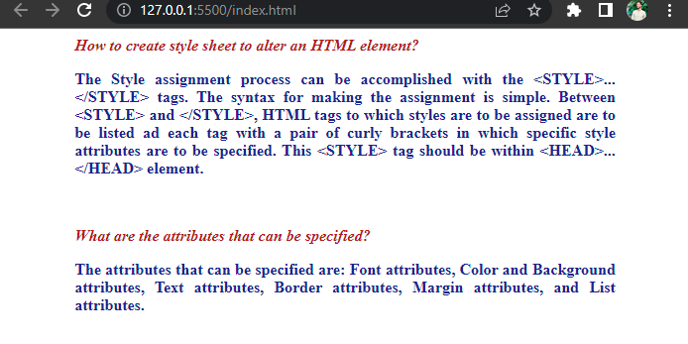

<!doctype html>

<html lang="en">

<head>

    <!-- Required meta tags -->

    <meta charset="utf-8">

    <meta name="viewport" content="width=device-width, initial-scale=1">

    <!-- Bootstrap CSS -->

    <link href="https://cdn.jsdelivr.net/npm/bootstrap@5.1.3/dist/css/bootstrap.min.css" rel="stylesheet"

        integrity="sha384-1BmE4kWBq78iYhFldvKuhfTAU6auU8tT94WrHftjDbrCEXSU1oBoqyl2QvZ6jIW3" crossorigin="anonymous">

    <title>Hello, world!</title>

    <style>

        html,

        body {

            height: 100%;

        }

        body {

            display: flex;

            align-items: center;

            padding-top: 40px;

            padding-bottom: 40px;

            background-color: #f5f5f5;

        }

        .form-signin {

            width: 100%;

            max-width: 330px;

            padding: 15px;

            margin: auto;

        }

        .form-signin .checkbox {

            font-weight: 400;

        }

        .form-signin .form-floating:focus-within {

            z-index: 2;

        }

        .form-signin input[type="email"] {

            margin-bottom: -1px;

            border-bottom-right-radius: 0;

            border-bottom-left-radius: 0;

        }

        .form-signin input[type="password"] {

            margin-bottom: 10px;

            border-top-left-radius: 0;

            border-top-right-radius: 0;

        }

    </style>

</head>

<body class="text-center">

    <main class="form-signin">

        <form>

            <img class="mb-4" src="./logo.jpg" alt="" width="72" height="57" style="border-radius: 50%;">

            <h1 class="h3 mb-3 fw-normal">Sign in</h1>

            <div class="form-floating">

                <input type="email" class="form-control" id="floatingInput" placeholder="name@example.com">

                <label for="floatingInput">Email address</label>

            </div>

            <div class="form-floating">

                <input type="password" class="form-control" id="floatingPassword" placeholder="Password">

                <label for="floatingPassword">Password</label>

            </div>

            <div class="checkbox mb-3">

                <label>

                    <input type="checkbox" value="remember-me"> Remember me

                </label>

            </div>

            <button class="w-100 btn btn-lg btn-primary" type="submit">Sign in</button>

            <p class="mt-5 mb-3 text-muted">&copy; Made by Abdul Majid</p>

        </form>

    </main>

    <script src="https://cdn.jsdelivr.net/npm/bootstrap@5.1.3/dist/js/bootstrap.bundle.min.js"

        integrity="sha384-ka7Sk0Gln4gmtz2MlQnikT1wXgYsOg+OMhuP+IlRH9sENBO0LRn5q+8nbTov4+1p"

        crossorigin="anonymous"></script>

</body>

</html>

Oupt put

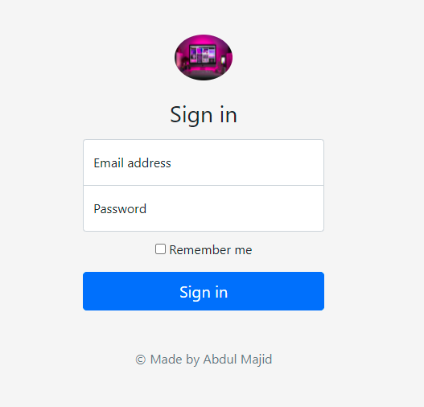

Cover page

Code

<!doctype html>

<html lang="en" class="h-100">

  <head>

    <meta charset="utf-8">

    <meta name="viewport" content="width=device-width, initial-scale=1">

    <meta name="description" content="">

    <meta name="author" content="Mark Otto, Jacob Thornton, and Bootstrap contributors">

    <meta name="generator" content="Hugo 0.88.1">

    <title>Cover Template · Bootstrap v5.1</title>

    <link rel="canonical" href="https://getbootstrap.com/docs/5.1/examples/cover/">

    <!-- Bootstrap core CSS -->

<link href="../assets/dist/css/bootstrap.min.css" rel="stylesheet">

    <style>

      .bd-placeholder-img {

        font-size: 1.125rem;

        text-anchor: middle;

        -webkit-user-select: none;

        -moz-user-select: none;

        user-select: none;

      }

      @media (min-width: 768px) {

        .bd-placeholder-img-lg {

          font-size: 3.5rem;

        }

      }

    </style>

    <!-- Custom styles for this template -->

    <link href="cover.css" rel="stylesheet">

  </head>

  <body class="d-flex h-100 text-center text-white bg-dark bgcustom">

<div class="cover-container d-flex w-100 h-100 p-3 mx-auto flex-column">

  <header class="mb-auto">

    <div>

      <h3 class="float-md-start mb-0">Cover</h3>

      <nav class="nav nav-masthead justify-content-center float-md-end">

        <a class="nav-link active" aria-current="page" href="#">Home</a>

        <a class="nav-link" href="#">Features</a>

        <a class="nav-link" href="#">Contact</a>

      </nav>

    </div>

  </header>

  <main class="px-3">

    <h1>My cover page.</h1>

    <p class="lead">My cover page</p>

    <p class="lead">

      <a href="#" class="btn btn-lg btn-secondary fw-bold border-white bg-white">Sign Up</a>

    </p>

  </main>

  <footer class="mt-auto text-white-50">

    <p>Cover template <a href="https://getbootstrap.com/" class="text-white">Bootstrap</a>, by <a href="https://twitter.com/mdo" class="text-white">@Majid</a>.</p>

  </footer>

</div>

  </body>

</html>

Output

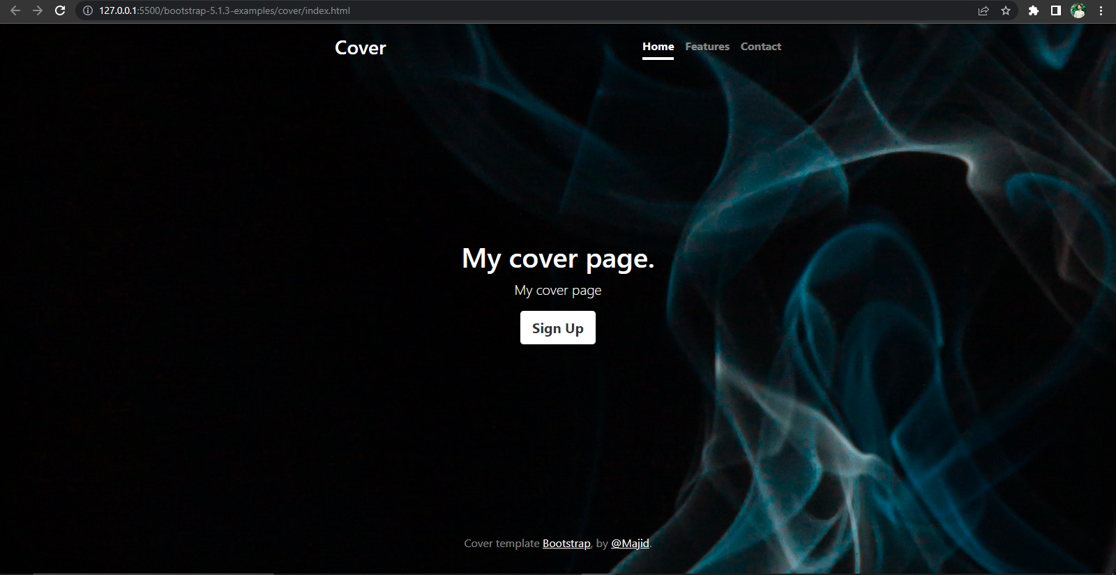

Checkout

Code

<!doctype html>

<html lang="en">

  <head>

    <meta charset="utf-8">

    <meta name="viewport" content="width=device-width, initial-scale=1">

    <meta name="description" content="">

    <meta name="author" content="Mark Otto, Jacob Thornton, and Bootstrap contributors">

    <meta name="generator" content="Hugo 0.88.1">

    <title>Checkout example · Bootstrap v5.1</title>

    <link rel="canonical" href="https://getbootstrap.com/docs/5.1/examples/checkout/">

    <!-- Bootstrap core CSS -->

<link href="../assets/dist/css/bootstrap.min.css" rel="stylesheet">

    <style>

      .bd-placeholder-img {

        font-size: 1.125rem;

        text-anchor: middle;

        -webkit-user-select: none;

        -moz-user-select: none;

        user-select: none;

      }

      @media (min-width: 768px) {

        .bd-placeholder-img-lg {

          font-size: 3.5rem;

        }

      }

    </style>

    <!-- Custom styles for this template -->

    <link href="form-validation.css" rel="stylesheet">

  </head>

  <body class="bg-light lc">

<div class="container">

  <main>

    <div class="py-5 text-center">

      <img class="d-block mx-auto mb-4" src="../../bg1.jpg" alt="" width="72" height="57">

      <h2>Checkout form</h2>

      <p class="lead"></p>

    </div>

    <div class="row g-5">

      <div class="col-md-5 col-lg-4 order-md-last">

        <h4 class="d-flex justify-content-between align-items-center mb-3">

          <span class="text-primary">Your cart</span>

          <span class="badge bg-primary rounded-pill">3</span>

        </h4>

        <ul class="list-group mb-3">

          <li class="list-group-item d-flex justify-content-between lh-sm">

            <div>

              <h6 class="my-0">Product name</h6>

              <small class="text-muted">Brief description</small>

            </div>

            <span class="text-muted">$12</span>

          </li>

          <li class="list-group-item d-flex justify-content-between lh-sm">

            <div>

              <h6 class="my-0">Second product</h6>

              <small class="text-muted">Brief description</small>

            </div>

            <span class="text-muted">$8</span>

          </li>

          <li class="list-group-item d-flex justify-content-between lh-sm">

            <div>

              <h6 class="my-0">Third item</h6>

              <small class="text-muted">Brief description</small>

            </div>

            <span class="text-muted">$5</span>

          </li>

          <li class="list-group-item d-flex justify-content-between bg-light">

            <div class="text-success">

              <h6 class="my-0">Promo code</h6>

              <small>EXAMPLECODE</small>

            </div>

            <span class="text-success">−$5</span>

          </li>

          <li class="list-group-item d-flex justify-content-between">

            <span>Total (USD)</span>

            <strong>$20</strong>

          </li>

        </ul>

        <form class="card p-2">

          <div class="input-group">

            <input type="text" class="form-control" placeholder="Promo code">

            <button type="submit" class="btn btn-secondary">Redeem</button>

          </div>

        </form>

      </div>

      <div class="col-md-7 col-lg-8">

        <h4 class="mb-3">Billing address</h4>

        <form class="needs-validation" novalidate>

          <div class="row g-3">

            <div class="col-sm-6">

              <label for="firstName" class="form-label">First name</label>

              <input type="text" class="form-control" id="firstName" placeholder="" value="" required>

              <div class="invalid-feedback">

                Valid first name is required.

              </div>

            </div>

            <div class="col-sm-6">

              <label for="lastName" class="form-label">Last name</label>

              <input type="text" class="form-control" id="lastName" placeholder="" value="" required>

              <div class="invalid-feedback">

                Valid last name is required.

              </div>

            </div>

            <div class="col-12">

              <label for="username" class="form-label">Username</label>

              <div class="input-group has-validation">

                <span class="input-group-text">@</span>

                <input type="text" class="form-control" id="username" placeholder="Username" required>

              <div class="invalid-feedback">

                  Your username is required.

                </div>

              </div>

            </div>

            <div class="col-12">

              <label for="email" class="form-label">Email <span class="text-muted">(Optional)</span></label>

              <input type="email" class="form-control" id="email" placeholder="you@example.com">

              <div class="invalid-feedback">

                Please enter a valid email address for shipping updates.

              </div>

            </div>

            <div class="col-12">

              <label for="address" class="form-label">Address</label>

              <input type="text" class="form-control" id="address" placeholder="1234 Main St" required>

              <div class="invalid-feedback">

                Please enter your shipping address.

              </div>

            </div>

            <div class="col-12">

              <label for="address2" class="form-label">Address 2 <span class="text-muted">(Optional)</span></label>

              <input type="text" class="form-control" id="address2" placeholder="Apartment or suite">

            </div>

            <div class="col-md-5">

              <label for="country" class="form-label">Country</label>

              <select class="form-select" id="country" required>

                <option value="">Choose...</option>

                <option>United States</option>

              </select>

              <div class="invalid-feedback">

                Please select a valid country.

              </div>

            </div>

            <div class="col-md-4">

              <label for="state" class="form-label">State</label>

              <select class="form-select" id="state" required>

                <option value="">Choose...</option>

                <option>California</option>

              </select>

              <div class="invalid-feedback">

                Please provide a valid state.

              </div>

            </div>

            <div class="col-md-3">

              <label for="zip" class="form-label">Zip</label>

              <input type="text" class="form-control" id="zip" placeholder="" required>

              <div class="invalid-feedback">

                Zip code required.

              </div>

            </div>

          </div>

          <hr class="my-4">

          <div class="form-check">

            <input type="checkbox" class="form-check-input" id="same-address">

            <label class="form-check-label" for="same-address">Shipping address is the same as my billing address</label>

          </div>

          <div class="form-check">

            <input type="checkbox" class="form-check-input" id="save-info">

            <label class="form-check-label" for="save-info">Save this information for next time</label>

          </div>

          <hr class="my-4">

          <h4 class="mb-3">Payment</h4>

          <div class="my-3">

            <div class="form-check">

              <input id="credit" name="paymentMethod" type="radio" class="form-check-input" checked required>

              <label class="form-check-label" for="credit">Credit card</label>

            </div>

            <div class="form-check">

              <input id="debit" name="paymentMethod" type="radio" class="form-check-input" required>

              <label class="form-check-label" for="debit">Debit card</label>

            </div>

            <div class="form-check">

              <input id="paypal" name="paymentMethod" type="radio" class="form-check-input" required>

              <label class="form-check-label" for="paypal">PayPal</label>

            </div>

          </div>

          <div class="row gy-3">

            <div class="col-md-6">

              <label for="cc-name" class="form-label">Name on card</label>

              <input type="text" class="form-control" id="cc-name" placeholder="" required>

              <small class="text-muted">Full name as displayed on card</small>

              <div class="invalid-feedback">

                Name on card is required

              </div>

            </div>

            <div class="col-md-6">

              <label for="cc-number" class="form-label">Credit card number</label>

              <input type="text" class="form-control" id="cc-number" placeholder="" required>

              <div class="invalid-feedback">

                Credit card number is required

              </div>

            </div>

            <div class="col-md-3">

              <label for="cc-expiration" class="form-label">Expiration</label>

              <input type="text" class="form-control" id="cc-expiration" placeholder="" required>

              <div class="invalid-feedback">

                Expiration date required

              </div>

            </div>

            <div class="col-md-3">

              <label for="cc-cvv" class="form-label">CVV</label>

              <input type="text" class="form-control" id="cc-cvv" placeholder="" required>

              <div class="invalid-feedback">

                Security code required

              </div>

            </div>

          </div>

          <hr class="my-4">

          <button class="w-100 btn btn-primary btn-lg" type="submit">Continue to checkout</button>

        </form>

      </div>

    </div>

  </main>

  <footer class="my-5 pt-5 text-muted text-center text-small">

    <p class="mb-1">&copy; 2017–2021 Abdul Majid</p>

    <ul class="list-inline">

      <li class="list-inline-item"><a href="#">Privacy</a></li>

      <li class="list-inline-item"><a href="#">Terms</a></li>

      <li class="list-inline-item"><a href="#">Support</a></li>

    </ul>

  </footer>

</div>

    <script src="../assets/dist/js/bootstrap.bundle.min.js"></script>

      <script src="form-validation.js"></script>

  </body>

</html>

Custom CSS

.container {

  max-width: 960px;

}

.lc{

  background-color: rgb(12, 22, 22) !important;

  color: whitesmoke

}

Output

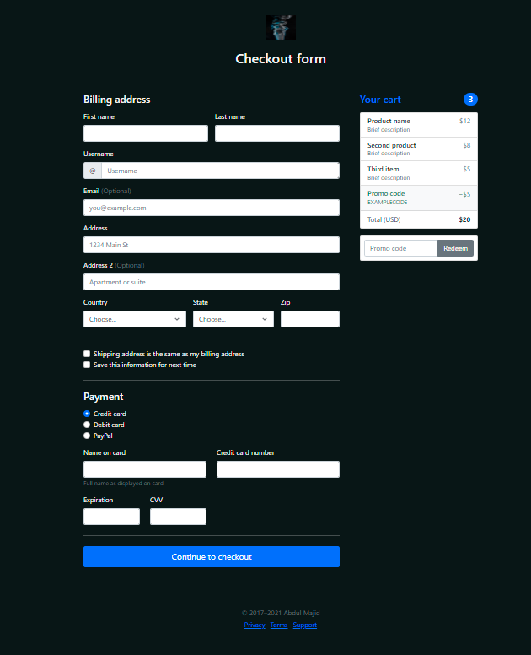

BLOG

Code

<!doctype html>

<html lang="en">

  <head>

    <meta charset="utf-8">

    <meta name="viewport" content="width=device-width, initial-scale=1">

    <meta name="description" content="">

    <meta name="author" content="Mark Otto, Jacob Thornton, and Bootstrap contributors">

    <meta name="generator" content="Hugo 0.88.1">

    <title>Blog Template · Bootstrap v5.1</title>

    <link rel="canonical" href="https://getbootstrap.com/docs/5.1/examples/blog/">

    <!-- Bootstrap core CSS -->

<link href="../assets/dist/css/bootstrap.min.css" rel="stylesheet">

.bodyclass{

  background-image: url(../../bg1.jpg);

  color: white;

}

    <style>

      .bd-placeholder-img {

        font-size: 1.125rem;

        text-anchor: middle;

        -webkit-user-select: none;

        -moz-user-select: none;

        user-select: none;

      }

      @media (min-width: 768px) {

        .bd-placeholder-img-lg {

          font-size: 3.5rem;

        }

      }

    </style>

    <!-- Custom styles for this template -->

    <link href="https://fonts.googleapis.com/css?family=Playfair&#43;Display:700,900&amp;display=swap" rel="stylesheet">

    <!-- Custom styles for this template -->

    <link href="blog.css" rel="stylesheet">

  </head>

  <body class="bodyclass" style="background-color: teal;">

<div class="container">

  <header class="blog-header py-3">

    <div class="row flex-nowrap justify-content-between align-items-center" >

      <div class="col-4 pt-1">

        <a class="link-secondary" href="#">Subscribe</a>

      </div >

      <div class="col-4 text-center" >

        <a class="blog-header-logo text-dark" href="#">My Blog page</a>

      </div>

      <div class="col-4 d-flex justify-content-end align-items-center">

        <a class="link-secondary" href="#" aria-label="Search">

          <svg xmlns="http://www.w3.org/2000/svg" width="20" height="20" fill="none" stroke="currentColor" stroke-linecap="round" stroke-linejoin="round" stroke-width="2" class="mx-3" role="img" viewBox="0 0 24 24"><title>Search</title><circle cx="10.5" cy="10.5" r="7.5"/><path d="M21 21l-5.2-5.2"/></svg>

        </a>

        <a class="btn btn-sm btn-outline-secondary" href="#">Sign up</a>

      </div>

    </div>

  </header>

  <div class="nav-scroller py-1 mb-2">

    <nav class="nav d-flex justify-content-between">

      <a class="p-2 link-secondary" href="#">World</a>

      <a class="p-2 link-secondary" href="#">U.S.</a>

      <a class="p-2 link-secondary" href="#">Technology</a>

      <a class="p-2 link-secondary" href="#">Design</a>

      <a class="p-2 link-secondary" href="#">Culture</a>

      <a class="p-2 link-secondary" href="#">Business</a>

      <a class="p-2 link-secondary" href="#">Politics</a>

      <a class="p-2 link-secondary" href="#">Opinion</a>

      <a class="p-2 link-secondary" href="#">Science</a>

      <a class="p-2 link-secondary" href="#">Health</a>

      <a class="p-2 link-secondary" href="#">Style</a>

      <a class="p-2 link-secondary" href="#">Travel</a>

    </nav>

  </div>

</div>

<main class="container">

  <div class="p-4 p-md-5 mb-4 text-white rounded bg-dark">

    <div class="col-md-6 px-0">

      <h1 class="display-4 fst-italic">Title of a longer featured blog post</h1>

      <p class="lead my-3">Multiple lines of text that form the lede, informing new readers quickly and efficiently about what’s most interesting in this post’s contents.</p>

      <p class="lead mb-0"><a href="#" class="text-white fw-bold">Continue reading...</a></p>

    </div>

  </div>

  <div class="row mb-2">

    <div class="col-md-6">

      <div class="row g-0 border rounded overflow-hidden flex-md-row mb-4 shadow-sm h-md-250 position-relative">

        <div class="col p-4 d-flex flex-column position-static">

          <strong class="d-inline-block mb-2 text-primary">World</strong>

          <h3 class="mb-0">Featured post</h3>

          <div class="mb-1 text-muted">Nov 12</div>

          <p class="card-text mb-auto">This is a wider card with supporting text below as a natural lead-in to additional content.</p>

          <a href="#" class="stretched-link">Continue reading</a>

        </div>

        <div class="col-auto d-none d-lg-block">

          <svg class="bd-placeholder-img" width="200" height="250" xmlns="http://www.w3.org/2000/svg" role="img" aria-label="Placeholder: Thumbnail" preserveAspectRatio="xMidYMid slice" focusable="false"><title>Placeholder</title><rect width="100%" height="100%" fill="#55595c"/><text x="50%" y="50%" fill="#eceeef" dy=".3em">Thumbnail</text></svg>

        </div>

      </div>

    </div>

    <div class="col-md-6">

      <div class="row g-0 border rounded overflow-hidden flex-md-row mb-4 shadow-sm h-md-250 position-relative">

        <div class="col p-4 d-flex flex-column position-static">

          <strong class="d-inline-block mb-2 text-success">Design</strong>

          <h3 class="mb-0">Post title</h3>

          <div class="mb-1 text-muted">Nov 11</div>

          <p class="mb-auto">This is a wider card with supporting text below as a natural lead-in to additional content.</p>

          <a href="#" class="stretched-link">Continue reading</a>

        </div>

        <div class="col-auto d-none d-lg-block">

          <svg class="bd-placeholder-img" width="200" height="250" xmlns="http://www.w3.org/2000/svg" role="img" aria-label="Placeholder: Thumbnail" preserveAspectRatio="xMidYMid slice" focusable="false"><title>Placeholder</title><rect width="100%" height="100%" fill="#55595c"/><text x="50%" y="50%" fill="#eceeef" dy=".3em">Thumbnail</text></svg>

        </div>

      </div>

    </div>

  </div>

  <div class="row g-5">

    <div class="col-md-8">

      <h3 class="pb-4 mb-4 fst-italic border-bottom">

        From the Firehose

      </h3>

      <article class="blog-post">

        <h2 class="blog-post-title">Sample blog post</h2>

        <p class="blog-post-meta">January 1, 2021 by <a href="#">Mark</a></p>

        <p>This blog post shows a few different types of content that’s supported and styled with Bootstrap. Basic typography, lists, tables, images, code, and more are all supported as expected.</p>

        <hr>

        <p>This is some additional paragraph placeholder content. It has been written to fill the available space and show how a longer snippet of text affects the surrounding content. We'll repeat it often to keep the demonstration flowing, so be on the lookout for this exact same string of text.</p>

        <h2>Blockquotes</h2>

        <p>This is an example blockquote in action:</p>

        <blockquote class="blockquote">

          <p>Quoted text goes here.</p>

        </blockquote>

        <p>This is some additional paragraph placeholder content. It has been written to fill the available space and show how a longer snippet of text affects the surrounding content. We'll repeat it often to keep the demonstration flowing, so be on the lookout for this exact same string of text.</p>

        <h3>Example lists</h3>

        <p>This is some additional paragraph placeholder content. It's a slightly shorter version of the other highly repetitive body text used throughout. This is an example unordered list:</p>

        <ul>

          <li>First list item</li>

          <li>Second list item with a longer description</li>

          <li>Third list item to close it out</li>

        </ul>

        <p>And this is an ordered list:</p>

        <ol>

          <li>First list item</li>

          <li>Second list item with a longer description</li>

          <li>Third list item to close it out</li>

        </ol>

        <p>And this is a definition list:</p>

        <dl>

          <dt>HyperText Markup Language (HTML)</dt>

          <dd>The language used to describe and define the content of a Web page</dd>

          <dt>Cascading Style Sheets (CSS)</dt>

          <dd>Used to describe the appearance of Web content</dd>

          <dt>JavaScript (JS)</dt>

          <dd>The programming language used to build advanced Web sites and applications</dd>

        </dl>

        <h2>Inline HTML elements</h2>

        <p>HTML defines a long list of available inline tags, a complete list of which can be found on the <a href="https://developer.mozilla.org/en-US/docs/Web/HTML/Element">Mozilla Developer Network</a>.</p>

        <ul>

          <li><strong>To bold text</strong>, use <code class="language-plaintext highlighter-rouge">&lt;strong&gt;</code>.</li>

          <li><em>To italicize text</em>, use <code class="language-plaintext highlighter-rouge">&lt;em&gt;</code>.</li>

          <li>Abbreviations, like <abbr title="HyperText Markup Langage">HTML</abbr> should use <code class="language-plaintext highlighter-rouge">&lt;abbr&gt;</code>, with an optional <code class="language-plaintext highlighter-rouge">title</code> attribute for the full phrase.</li>

          <li>Citations, like <cite>— Mark Otto</cite>, should use <code class="language-plaintext highlighter-rouge">&lt;cite&gt;</code>.</li>

          <li><del>Deleted</del> text should use <code class="language-plaintext highlighter-rouge">&lt;del&gt;</code> and <ins>inserted</ins> text should use <code class="language-plaintext highlighter-rouge">&lt;ins&gt;</code>.</li>

          <li>Superscript <sup>text</sup> uses <code class="language-plaintext highlighter-rouge">&lt;sup&gt;</code> and subscript <sub>text</sub> uses <code class="language-plaintext highlighter-rouge">&lt;sub&gt;</code>.</li>

        </ul>

        <p>Most of these elements are styled by browsers with few modifications on our part.</p>

        <h2>Heading</h2>

        <p>This is some additional paragraph placeholder content. It has been written to fill the available space and show how a longer snippet of text affects the surrounding content. We'll repeat it often to keep the demonstration flowing, so be on the lookout for this exact same string of text.</p>

        <h3>Sub-heading</h3>

        <p>This is some additional paragraph placeholder content. It has been written to fill the available space and show how a longer snippet of text affects the surrounding content. We'll repeat it often to keep the demonstration flowing, so be on the lookout for this exact same string of text.</p>

        <pre><code>Example code block</code></pre>

        <p>This is some additional paragraph placeholder content. It's a slightly shorter version of the other highly repetitive body text used throughout.</p>

      </article>

      <article class="blog-post">

        <h2 class="blog-post-title">Another blog post</h2>

        <p class="blog-post-meta">December 23, 2020 by <a href="#">Jacob</a></p>

        <p>This is some additional paragraph placeholder content. It has been written to fill the available space and show how a longer snippet of text affects the surrounding content. We'll repeat it often to keep the demonstration flowing, so be on the lookout for this exact same string of text.</p>

        <blockquote>

          <p>Longer quote goes here, maybe with some <strong>emphasized text</strong> in the middle of it.</p>

        </blockquote>

        <p>This is some additional paragraph placeholder content. It has been written to fill the available space and show how a longer snippet of text affects the surrounding content. We'll repeat it often to keep the demonstration flowing, so be on the lookout for this exact same string of text.</p>

        <h3>Example table</h3>

        <p>And don't forget about tables in these posts:</p>

        <table class="table">

          <thead>

            <tr>

              <th>Name</th>

              <th>Upvotes</th>

              <th>Downvotes</th>

            </tr>

          </thead>

          <tbody>

            <tr>

              <td>Alice</td>

              <td>10</td>

              <td>11</td>

            </tr>

            <tr>

              <td>Bob</td>

              <td>4</td>

              <td>3</td>

            </tr>

            <tr>

              <td>Charlie</td>

              <td>7</td>

              <td>9</td>

            </tr>

          </tbody>

          <tfoot>

            <tr>

              <td>Totals</td>

              <td>21</td>

              <td>23</td>

            </tr>

          </tfoot>

        </table>

        <p>This is some additional paragraph placeholder content. It's a slightly shorter version of the other highly repetitive body text used throughout.</p>

      </article>

      <article class="blog-post">

        <h2 class="blog-post-title">New feature</h2>

        <p class="blog-post-meta">December 14, 2020 by <a href="#">Chris</a></p>

        <p>This is some additional paragraph placeholder content. It has been written to fill the available space and show how a longer snippet of text affects the surrounding content. We'll repeat it often to keep the demonstration flowing, so be on the lookout for this exact same string of text.</p>

        <ul>

          <li>First list item</li>

          <li>Second list item with a longer description</li>

          <li>Third list item to close it out</li>

        </ul>

        <p>This is some additional paragraph placeholder content. It's a slightly shorter version of the other highly repetitive body text used throughout.</p>

      </article>

      <nav class="blog-pagination" aria-label="Pagination">

        <a class="btn btn-outline-primary" href="#">Older</a>

        <a class="btn btn-outline-secondary disabled">Newer</a>

      </nav>

    </div>

    <div class="col-md-4">

      <div class="position-sticky" style="top: 2rem;">

        <div class="p-4 mb-3 bg-light rounded">

          <h4 class="fst-italic">About</h4>

          <p class="mb-0">Customize this section to tell your visitors a little bit about your publication, writers, content, or something else entirely. Totally up to you.</p>

        </div>

        <div class="p-4">

          <h4 class="fst-italic">Archives</h4>

          <ol class="list-unstyled mb-0">

            <li><a href="#">March 2021</a></li>

            <li><a href="#">February 2021</a></li>

            <li><a href="#">January 2021</a></li>

            <li><a href="#">December 2020</a></li>

            <li><a href="#">November 2020</a></li>

            <li><a href="#">October 2020</a></li>

            <li><a href="#">September 2020</a></li>

            <li><a href="#">August 2020</a></li>

            <li><a href="#">July 2020</a></li>

            <li><a href="#">June 2020</a></li>

            <li><a href="#">May 2020</a></li>

            <li><a href="#">April 2020</a></li>

          </ol>

        </div>

        <div class="p-4">

          <h4 class="fst-italic">Elsewhere</h4>

          <ol class="list-unstyled">

            <li><a href="#">GitHub</a></li>

            <li><a href="#">Twitter</a></li>

            <li><a href="#">Facebook</a></li>

          </ol>

        </div>

      </div>

    </div>

  </div>

</main>

<footer class="blog-footer">

  <p>Blog template built for <a href="https://getbootstrap.com/">Bootstrap</a> by <a href="https://twitter.com/mdo">@mdo</a>.</p>

  <p>

    <a href="#">Back to top</a>

  </p>

</footer>

  </body>

</html>

Output

